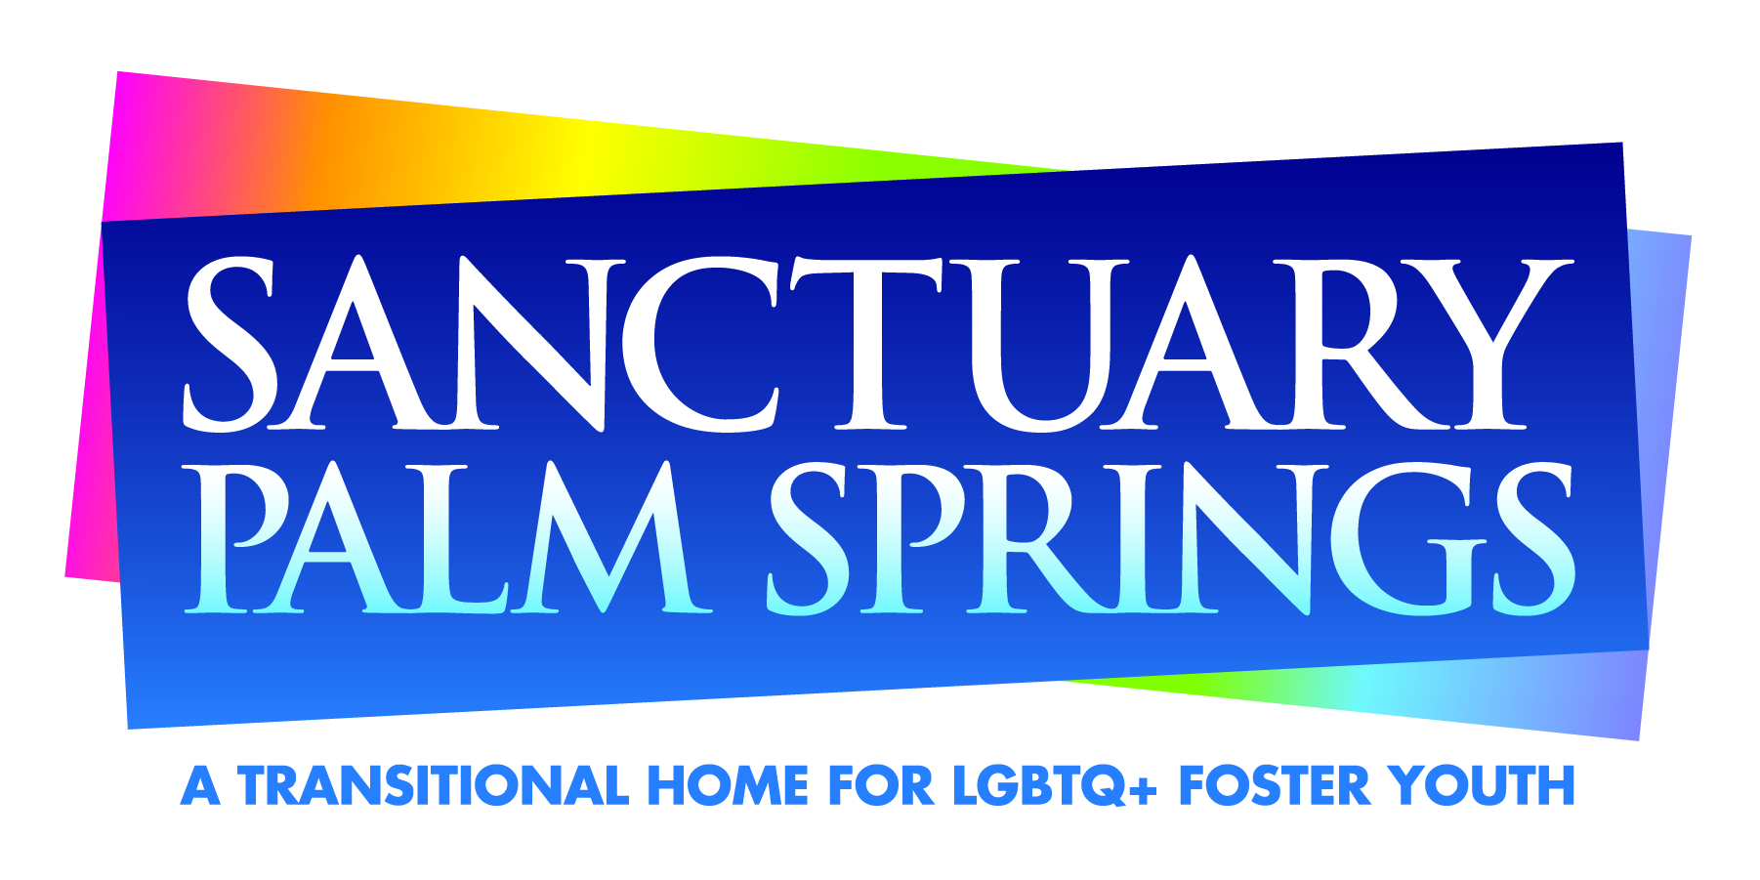
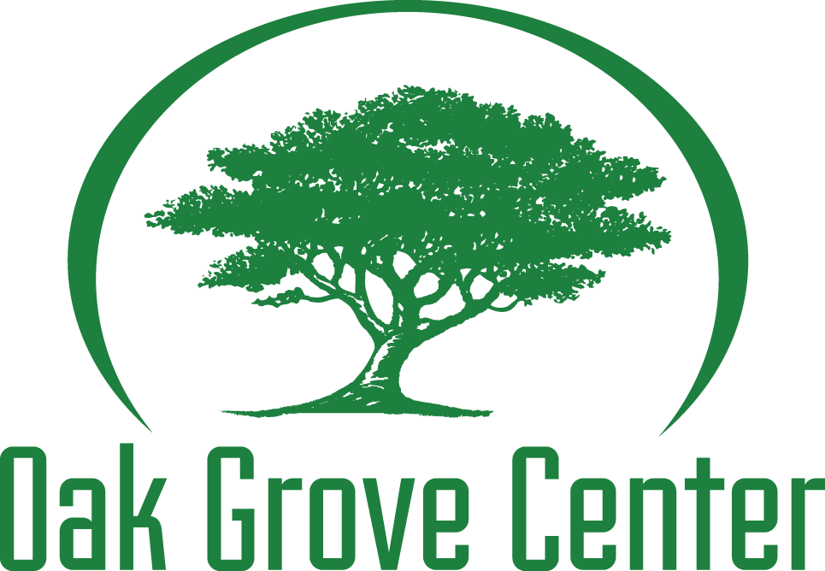
NEWS RELEASE
MEDIA Contact: O’Bayley Communications – Tim O’Bayley • 760-778-3525 • tim@obayley.net
or Oak Grove Center – Tammy Wilson, C.E.O. • (951) 677-5599 x 2259 • tammyw@oakgrovecenter.org

Sanctuary Palm Springs and Oak Grove Center Announce Merger
LGBTQ+ Transitional Housing Program and Related Services Continue with Greater Stability

January X, 2021 - Palm Springs, California – The boards of directors of Sanctuary Palm Springs and Oak Grove Center are pleased to announce that effective ____(date)___, Sanctuary will become a program of Oak Grove Center. The people behind Sanctuary Palm Springs and Oak Grove Center both envision a world where every child has an opportunity to realize their greatest potential toward becoming a self-sufficient and productive member of their community.

Former Board Chair of Sanctuary, Barry McCabe, said of the change: “Being part of Oak Grove Center makes Sanctuary stronger and increases our capabilities to continue our mission to prepare LGBTQ+ foster youth for a happy, successful adulthood. Without the need to dedicate so much of the funds we raise to cover administrative expenses, donations to Sanctuary Palm Springs will allow us to expand our programming beyond the current Transitional Housing Program (THP). Nothing about Sanctuary’s mission to serve LGBTQ+ transition age foster youth will change.” He added “This new partnership means that we will no longer need to dedicate so much of our raised funds to cover administrative expenses. Future donations to Sanctuary Palm Springs will now be exclusively applied to expanding our programming beyond our current Transitional Housing Program (THP).”

Sanctuary will become a part of an enormously influential human services treatment organization that will have the power to inform and improve the care that LGBTQ+ foster youth receive at the local, county, statewide, and national levels. Oak Grove Center is part of the California Alliance which advocates for the needs of foster youth, education, LGBTQ+ population and at-risk special needs population throughout California and provides support on political representation and equity issues.

Sanctuary residents will have access to Oak Grove Center’s broad range of supportive programs and services including arts and music programs, their THRIVE Independent Living Skills Program, some support for sports programming, and access to behavioral health services. These are services that Sanctuary could not provide on its own. Oak Grove is proud to have been part of educating Sanctuary residents on issues related to launching successfully into adulthood through these THRIVE classes over the past 4 years. In addition, Sanctuary residents have been instrumental in choosing a senior living facility as the repeat beneficiary of THRIVE’s “Giving Back Project.” They have enjoyed spending time, working on art projects, and sharing a meal with the senior care residents. This supports Sanctuary’s belief that volunteering and giving back is an important component in being part of a community.

Oak Grove Center has cared for thousands of children, youth, and families since it was established more than 30 years ago. Founded in 1989, Oak Grove Center is a nonprofit Residential, Education, and Treatment Center (with multiple campuses) for at-risk and special

needs youth. Oak Grove’s mission is to rebuild the lives of at-risk children and their families through educating, healing, restoring relationships, building character, and instilling hope.

Oak Grove Center has earned a unique combination of prized licenses and accreditations, including Joint Commission on Accreditation of Healthcare Organizations (JCAHO) and Western Association of Schools and Colleges (WASC).

“Oak Grove is committed to improving the health and wellbeing of ALL young people, including LGBTQ + youth, and we are eager to embrace Sanctuary Palm Springs and ensure the health and wellbeing of the youth Sanctuary was created to serve,” said Tammy Wilson, C.E.O. of Oak Grove Center. “Partnering with Oak Grove will allow Sanctuary to expand their programing to include the development of Scattered Sites with Supervised Independent Living Placements (SILP), apartments into which Sanctuary’s residents may transition once they have learned essential life skills while living in the THP Single Site Home or who may be transitioning from another placement and are already able to function more independently. The goal is to increase services that match the needs of LGBTQ+ young adults in need of housing with the appropriate level of support.”

McCabe added, “It has proven to be extremely difficult for Sanctuary to receive the types of large foundation grants we need to support our programs and services because foundations are reluctant to award large grants ($50,000+) to a small organization that only serves 6 - 11 residents, leaving the burden on our local donor community to raise funds beyond the reimbursements we receive from the state. Being a part of an organization that serves more than 1,500 children and youth each year will make Sanctuary much more attractive to larger foundations than it could ever be on its own.”

Jeremy W. Hobbs is President of the Western Wind Foundation, a private foundation working primarily on social and economic development and education, with a geographic focus on the Coachella Valley. A long-time supporter of Sanctuary, Jeremy related his approval of the change: “I’m excited to hear about the merger between Oak Grove Center and Sanctuary Palm Springs. So many non-profit organizations in our area do excellent work, and mergers and consolidations make so much sense, especially in these difficult times. I’ve had the privilege of being involved with Sanctuary since pre-opening planning in 2016. Sanctuary’s mission has always been fantastic, and its founders, leaders, volunteers, and supporters have shown an astonishing passion for the mission and the young people who are building their lives at Sanctuary. This merger will assure that the mission will continue, more LGBTQ youth will grow into a safe and healthy adulthood, and our community will be even better served. Special kudos to (Sanctuary C.E.O.) Rob Woronoff, whose passion and dedication has built this organization and whose tireless efforts led to this merger, and to Ellen Wolf who has built a successful, engaged group of supporters and a strong financial base for Sanctuary.”

The majority of Sanctuary’s staff will become employees of Oak Grove Center to continue their work with Sanctuary and will have improved benefits as a result. An Advisory Board of former Sanctuary board members will be assembled, and two members of Sanctuary’s board of directors will join Oak Grove’s governing board.

More information about Oak Grove Center, including descriptions of their programs and services, can be found at oakgrovecenter.org

# # #

